**I – Introduction**

Philip Morris International (PMI), British American Tobacco (BAT), and Japan Tobacco Inc. (JPI) are among the chief players in the Vietnamese tobacco market. Thus, an understanding of the rate at which their new products enter the market and current intellectual property barriers might be crucial to policy reform processes aimed at smoking reduction.

This report presents an exploratory analysis we conducted on the Industrial Property Digital Library of the National Office of Intellectual Property of Vietnam (OIP). Our goal is to identify the characteristics of trademarks registered by these three corporations from 1/1/2015 to 30/6/2019.

**II – Methodology**

1. Data retrieval

Using a Python web scraper, we retrieved information of all category-34 (tobacco-related) trademarks registered to the National Office of Intellectual Property of Vietnam from 1/1/2015 to 30/6/2019 (See query in Figure 1). We then used the keywords “Philip Morris”, “Philip-Morris”, “British American”, “CTBAT”, and “Japan Tobacco” to select trademarks from Phillip Morris International (PMI), British American Tobacco (BAT) and Japan Tobacco International (JTI) branches. The dataset has 12 columns whose names and value types are presented in Table 1.

To preserve image quality and ease of lookup, information regarding the trademarks are presented in the accompanying Excel file.

2. Data cleaning

We conducted our analysis in a Jupyter notebook, using Python as our programming language.

For ease of analysis, we reformatted the retrieved data as follows:

1. All the dates in the dataset are formatted as DD/MM/YYYY
2. Duplicated phrases in the ‘APPLICANT / RIGHT HOLDER’ column are eliminated. For example, “British American Tobacco (Brands) Inc. / British American Tobacco (Brands) Inc.” is modified into “British American Tobacco (Brands) Inc.“
3. NaN values are converted into ‘0’.
4. Variable codification

2.1. Product type

Based on the information in the ‘GOODS / SERVICES’ column, we assigned 1 to trademarks of type 34 whose description contains ‘Cigarettes; tobacco, raw or processed; tobacco products’, 2 to trademarks of type 11 and trademarks of type 34 whose names contain ‘heating system’, ‘THS’, ‘Heatbar’ or ‘Heat not burn’, and 3 to trademarks of type 34 whose description contains ‘Bio-gas generator for electronic cigarettes’.

2.2. Status

Based on the information presented in the Chukan Code, we assigned 0 to rejected trademarks, 1 to pending ones, and 2 to those that have been approved/granted.

3. Analysis

Our goal was to answer six questions:

1. What is the number of trademarks submitted by each company in 2015 – 2019? What is the proportion of these numbers with regard to the total number of tobacco-related trademarks submitted to the National Office of Intellectual Property every year?

2. What is the trend in the number of submitted trademarks from each company throughout the months?

3. What are the branches of each company that registered trademarks in Vietnam?

4. What is the distribution of trademark color in each company?

5. What is the proportion of product types from each company?

6. What is the number of denied/pending/approved trademarks from each company?

To answer these questions, we need to analyze two datasets. The first dataset (dubbed ‘all’ for convenience) contains all tobacco-related trademarks registered National Office of Intellectual Property of Vietnam from 1/1/2015 to 30/6/2019. The second dataset (dubbed ‘main’ for convenience) contains all PMI, BAT and JPI trademarks registered National Office of Intellectual Property of Vietnam from 1/1/2015 to 30/6/2019.

From each dataset, we counted the number of trademarks registered by year, checked the prevalence of ‘GOODS / SERVICES’ types, and calculated the proportion of applicants/right holder, color, product type and status. We then compared the results of the two datasets to see whether any of the three companies deviated from the general trend.

**III – Findings**

1. Number of trademarks registered by year

During the four-year period, PMI and BAT trademarks accounted for a notable portion of all entries (7.0% and 6.1% respectively) (Table 2), while JPI’s contribution was not significant (0.7%) (Table 2).

PMI and BAT have proved their ability to quickly flood the Vietnamese market with new brands. Specifically, in 2015, BAT registered 45 trademarks, accounting for 20.0% of all trademarks registered that year (Table 2). Similarly, in 2016, PMI registered 53 trademarks, accounting for 23.5% of all registered trademarks (Table 2). With low rejection rates (only 4 PMI trademarks (7.5%) and 13 BAT trademarks (28%) were rejected in these instances), a significant number of new PMI or BAT entered Vietnam in just a short year.

Trend-wise, while the total number of registered tobacco-related trademarks increased continuously from 2015 to 2018, the number of trademarks from our three companies either decreased or stabilized. Specifically, the number of BAT trademarks drastically decreased after 2015, leveling off at around 10 during the next three years. Similarly, after the spike in 2016, the number of PMI trademarks steadily decreased, reaching a bottom of 12 in 2018. On the other hand, the number of JPI trademarks were stable at around 2 – 3 during the four years.

PMI was the only company of the three to have registered a trademark in 2019.

2. Trends in the number of submitted trademarks from each company by month

Most of the time, the number of registered trademarks from each of the three company did not exceed 5 per month, which was not enough to skew the total monthly trademark count. An obvious exception to this rule was February 2016 when PMI entries significantly increased the total count that month (Figure 2). Specifically, there were 34 PMI trademarks out of the 54 registered (62.9%), all of which dated 26/2/2016 (Figure 3).

In addition, PMI tended to register more than one trademark in a month. Specifically, there were PMI registered trademarks in 22 months during the 1/1/2015 – 30/6/2019 period, only 3 of which (13.6%) saw one single entry (Figure 3). On the other hand, BAT was as likely to file one entry as more than one in a month. In particular, they registered trademarks in 24 months from 1/1/2015 to 30/6/2019, 12 of which (50%) saw one single entry (Figure 3).

3. Branch demographic

PMI and BAT each had four branches registering their trademarks in Vietnam, while JTI only had one branch (Table 3).

Venture businesses tended to register fewer trademarks than company-owned branches. For example, Vinataba – Philip Morris Co. Ltd, the only PMI-related venture business in our dataset, only registered 3 trademarks (3.3% of all registered PMI trademarks), much fewer than Philip Morris Brands Sàrl or Philip Morris Products S.A (Table 3). Similarly, CTBAT International Co. Limited, the only BAT-related venture business in our dataset, registered 19 trademarks (24% of all registered BAT trademarks), much fewer than British American Tobacco (Brands) Inc. or British American Tobacco (Brands) Limited (Table 3).

4. Trademark color distribution

Overall, the color 0 is more likely to be chosen over 1 by 1.5 – 3 times (Table 4).

5. Product type proportion

Overall, traditional cigarettes still account for a great majority of all registered trademarks (Table 5). In fact, all JTI trademarks in Vietnam are cigarettes (Table 5).

BAT introduced one heated tobacco product, Neostiks, in 2016. This trademark was approved and remained the company’s only non-traditional-cigarette product in Vietnam as of 30/6/2019. Information on this trademark is detailed in the accompanying Excel file.

PMI introduced the most non-traditional-cigarette trademarks, including both heated tobacco products (6.7%) and e-cigarettes (2.2%) (Table 5). All 6 of their heated tobacco products (HTS) were registered in 2016 and 2017, while both of their e-cigarette (ENDS) products were registered in January 2018. As of 30/6/2019, 2 HTS have been approved, and none of these non-traditional trademarks have been denied. Information on these trademarks are detailed in the accompanying Excel file.

6. Trademark status from each company

For all three companies, the number of approved trademarks outweighed the number of disapproved ones (Table 6).

The longest-pending trademark, owned by PMI, dates back to 2015 (Table 7). Most trademarks registered in 2017, and all trademarks registered in 2018 and 2019 are pending (Table 7).

**IV – Conclusion and Recommendations**

The increase in the total number of registered trademarks from 2015 to 2019 shows that more tobacco companies are taking an increased interest in the Vietnamese market. However, to determine whether an increase in number of trademarks is associated with an increase in demand and consumption, we need to collect more information on each trademark’s sales volume, both through mainstream and contraband sources.

Regarding the decrease in the number of BAT and PMI trademarks, we need more information on the sales volume of their existing brands in Vietnam to determine whether this decrease is due to reduced interest in the Vietnamese market or the increasing profitability of current products.

The prevalence of approved trademarks over denied ones shows that the Vietnamese government may further reduce smoking rate by limiting the number of new tobacco-related products from entering the country. This might be achieved through the tightening of their current intellectual property laws and procedures. Research on how other governments limit the introduction of toxic goods through intellectual property laws might aid in this reform process.

**Figure 1. Query for tobacco-related trademarks in the Industrial Property Digital Library**

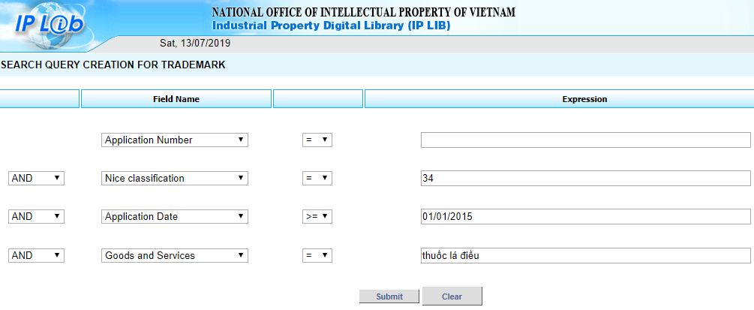

**Figure 2. Total number of cigarette-related trademarks by month**

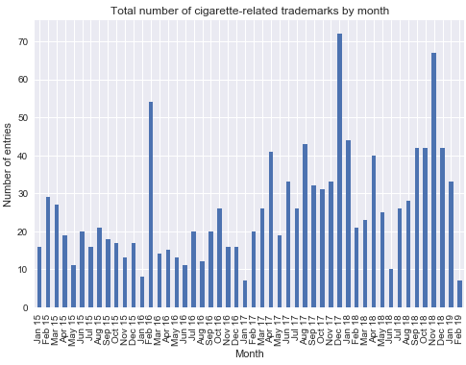

**Figure 3. Number of registered trademarks from each company by month**

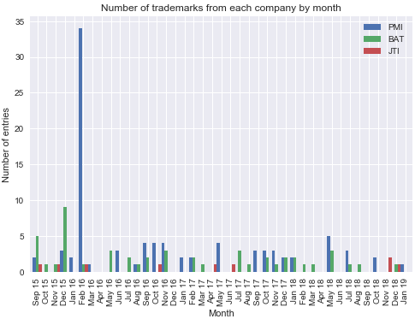

**Table 1. Description of columns in the dataset**

|  |  |  |
| --- | --- | --- |
| **Column name** | **Value type** | **Description** |
| **APP. NUMBER** | Text string | Unique identification number of each trademark |
| **APPLICANT / RIGHT HOLDER** | Text string | Name of the company registering the trademark with the National Office of Intellectual Property of Vietnam |
| **APP. DATE** | Date | Date of registration |
| **TRADEMARK** | Text string | Name of the trademark |
| **TM TYPE** | Text string | Trademark type. All values in the dataset are ‘Normal’. |
| **TM COLOR** | Numeric | Trademark color. Possible values are 0 and 1. |
| **GOODS/ SERVICES** | Text string | Description of Goods/services type. Values in the dataset include variations of category 09, 11, 34, 35, 41, and 42. |
| **PRODUCT TYPE** | Numeric | Product type. Values include 1 = cigarette, 2 = HTP, 3 = ENDS, and 4 = Other (e.g. accessory) |
| **CHUKAN CODE** | Text string | Timeline of the approval/disapproval process |
| **STATUS** | Numeric | Approval/Disapproval status of the trademark, determined based on the Chukan code. Values include 0 = denied, 1 = pending, and 2 = approved/granted |
| **IMAGE LINK** | Link | Link to the image of the trademark |
| **PICTURE** | Image | Picture of the trademark |

**Table 2. Number of registered trademarks by year**

|  |  |  |  |  |
| --- | --- | --- | --- | --- |
| **Year** | **Annual total** | **PMI trademarks** | **BAT trademarks** | **JPI trademarks** |
| **2015** | 224 | 5 (2.2%) | 45 (20.0%) | 3 (1.3%) |
| **2016** | 225 | 53 (23.5%) | 12 (5.3%) | 2 (0.8%) |
| **2017** | 383 | 19 (4.9%) | 12 (3.1%) | 2 (0.5%) |
| **2018** | 410 | 12 (2.9%) | 10 (2.4%) | 3 (0.7%) |
| **Until 6/2019** | 40 | 1 (2.5%) | 0 | 0 |
| **Total** | **1282** | **90 (7.0%)** | **79 (6.1%)** | **10 (0.7%)** |

**Table 3. Company branches that registered trademarks in Vietnam**

|  |  |  |
| --- | --- | --- |
| **Company** | **Branch** | **# Trademarks** |
| **PMI** | Philip Morris (Pakistan) Limited | 1 (1.1%) |
| Philip Morris Brands Sàrl | 58 (64.4%) |
| Philip Morris Products S.A. | 28 (31.1%) |
| Vinataba – Philip Morris Co. Ltd | 3 (3.3%) |
| **BAT** | British American Tobacco (Brands) Inc. | 32 (40.5%) |
| British American Tobacco (Brands) Limited | 27 (34.1%) |
| British American Tobacco (Germany) GmbH | 1 (1.2%) |
| CTBAT International Co. Limited | 19 (24.0%) |
| **JTI** | Japan Tobacco Inc. | 10 (100.0%) |

**Table 4. Distribution of trademark color**

|  |  |  |  |  |
| --- | --- | --- | --- | --- |
| **Trademark color** | **All** | **PMI** | **BAT** | **JTI** |
| **0** | 965 (75.3%) | 67 (74.4%) | 48 (60.8%) | 7 (70.0%) |
| **1** | 317 (24.7%) | 23 (25.6%) | 31 (39.2%) | 3 (30.0%) |

**Table 5. Product type proportion**

|  |  |  |  |
| --- | --- | --- | --- |
| **Product type** | **PMI** | **BAT** | **JTI** |
| Cigarettes | 82 (91.1%) | 78 (98.7%) | 10 (100.0%) |
| Heated Tobacco Products (HTS) | 6 (6.7%) | 1 (1.3%) | 0 |
| E-cigarettes (ENDS) | 2 (2.2%) | 0 | 0 |

**Table 6. Approval/denial status of each company**

|  |  |  |  |
| --- | --- | --- | --- |
|  | **PMI** | **BAT** | **JPI** |
| **Denied** | 9 (10.0%) | 18 (22.8%) | 1 (10.0%) |
| **Pending** | 35 (38.9%) | 21 (26.6%) | 5 (50.0%) |
| **Approved** | 46 (51.1%) | 40 (50.6%) | 4 (40.0%) |

**Table 7. Approval/denial status of each company by year**

|  |  |  |  |  |
| --- | --- | --- | --- | --- |
| **Year** | **Status** | **PMI** | **BAT** | **JTI** |
| **2015** | **Denied** | 3 | 13 | 1 |
| **Pending** | 1 | 0 | 0 |
| **Approved** | 1 | 32 | 2 |
| **2016** | **Denied** | 4 | 4 | 0 |
| **Pending** | 6 | 1 | 0 |
| **Approved** | 3 | 7 | 2 |
| **2017** | **Denied** | 2 | 0 | 0 |
| **Pending** | 15 | 11 | 2 |
| **Approved** | 2 | 1 | 0 |
| **2018** | **Pending** | 12 | 9 | 3 |
| **2019** | **Pending** | 1 | 0 | 0 |